My role in Shopee is “Algorithm Engineer” and I’m a team member of “Promotion Intelligence” team. “Promotion Intelligence” (PI) team is a sub-team of the Marketplace Intelligence team, Engineering. The main goal of PI team is to leverage AI and data science to promote business and mission of Shopee by building data-driven products which maximize the effectiveness of promotion tools both during BAU and campaign periods as well as providing personalized e-commerce experiences for all Shopee’s users.

Specifically, one major responsibility of the PI team is to design and develop recommendation systems which aim to improve users’ experience by providing personalized contents including but not limited to vouchers, flash sale products, etc.

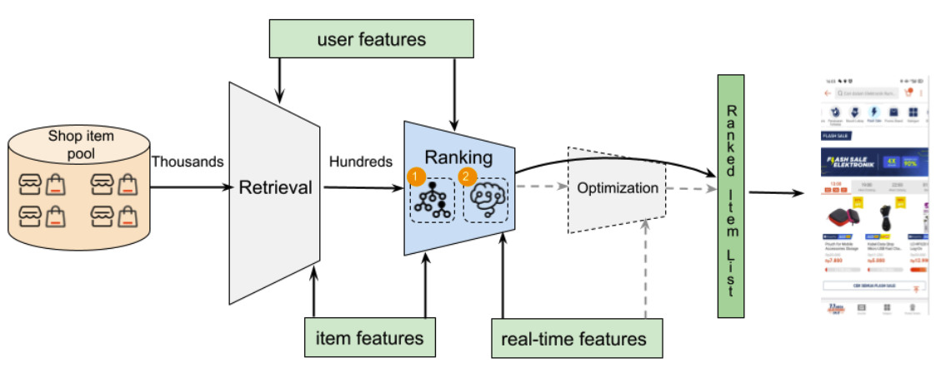

As full time employee, my job in Shopee mainly focus on optimizing performance of recall module and ranker, while also participating new project launch supporting. Recall and ranker are the two most important modules in the recommendation system. Technically, a ranker could be a classic machine learning model (e.g. GBDT) or a deep learning neural network. It should have the ability to rank the given items based on users’ preferences by leveraging properties of users and items. Every ranking model relies heavily on the input features. Thus, I plan to understand and practice how features are iterated in the recommendation ranker module.

In the past two weeks, I developed a simple machine learning model for trending keyword detection. By detecting what is trending, we can prepare corresponding special item collections that targeting people who searched those keyword, and hence lead to order placed.

I also started build “query” feature from last week. One of the new projects I am doing now is search. Search is slightly different from recommendation system as it will involve a new filed which is the query user searched. By now we only have item and user features and in order to support recommendation in search results, we will also need query features. These features are now under discussion and hopefully can be prepared in next two weeks.